## MCQs Carbon and Its Compounds

1. Which of the following statements are correct for carbon compounds?  
(i) Most carbon compounds are good conductors of electricity.

(ii) Most carbon compounds are poor conductors of electricity.

(iii) Force of attraction between molecules of carbon compounds is not very strong.  
(iv) Force of attraction between molecules of carbon compounds is very strong.  
(a) (ii) and (iv)  
(b) (ii) and (iii)  
(c) (i) and (iv)  
(d) (i) and (iii)

**Answer**

2. C3H8 belongs to the homologous series of  
(a) Alkynes  
(b) Alkenes  
(c) Alkanes  
(d) Cyclo alkanes

**Answer**

3.  
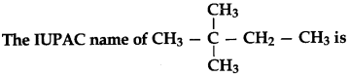  
(a) 2-ethyl-2-methyl propane  
(b) 2, 2-demethyl butane  
(c) 1,1,1-trimethyl propane  
(d) 2, 2-methyl butane

**Answer**

4. Which of the following is the formula of Butanoic acid?  
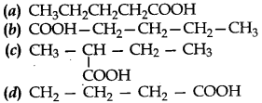

**Answer**

5. The number of isomers of pentane is  
(a) 2  
(b) 3  
(c) 4  
(d) 5

**Answer**

6. Which of the following will undergo addition reactions?  
(a) CH4  
(b) C3H8  
(C) C2H6  
(d) C2H4

**Answer**

7. When ethanoic acid is treated with NaHCO^ the gas evolved is  
(a) H2  
(b) CO2  
(c) CH4  
(d) CO

**Answer**

8. Ethanol on complete oxidation gives  
(a) acetic acid/ethanoic acid  
(b) CO2 and water  
(c) ethanal  
(d) acetone/ethanone

**Answer**

9. Which of the following will give a pleasant smell of ester when heated with ethanol and a small quantity of sulphuric acid?  
(a) CH3COOH  
(b) CH3CH2OH  
(c) CH3OH  
(d) CH3CHO

**Answer**

10. Name the functional group present in CH3COCH3.  
(a) Alcohol  
(b) Carboxylic acid  
(c) Ketone  
(d) Aldehyde

**Answer**

11. Why does carbon form compounds mainly by covalent bonding?  
(a) There are four electrons in the outermost shell of carbon.  
(b) It requires large amount of energy to form C4+ or C4sup>4-.  
(c) It shares its valence electrons to complete its octet.  
(d) All the above.

**Answer**

12. Addition reactions are undergone by  
(a) saturated hydrocarbons (alkanes)  
(b) only alkenes  
(c) only alkynes  
(d) both alkenes and alkynes

**Answer**

13. Identify ‘A’ in the following reaction:  
CH3COOH + Na2CO3 → A + CO2 + H0O  
(a) CH3COONa  
(b) CH2(Na)COOH  
(c) NaOH  
(d) NaHCO3

**Answer**

14. Which of the following belongs to homologous series of alkynes?  
C6H6, C2H6, C2H4, C3H4.  
(a) C6H6  
(b) C2H4  
(C) C2H6  
(d) C3H4

**Answer**

15. A hydrocarbon has four carbon atoms. Give its molecular formula if it is an alkene.  
(a) C4H10  
(b) C4H8  
(C) C4H6  
(d) C4H4

**Answer**

16. Identify A and B  
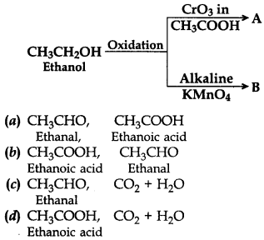

**Answer**

17. Give the IUPAC name of CH3COOC2H5.  
(a) Ethyl ethanoic acid  
(b) Butanoate  
(c) Ethyl ethanoate  
(d) Etyl methyl carboxylic acid

**Answer**

18. The firSt member of the alkyne homologous series is  
(a) propyne  
(b) ethyne  
(c) methane  
(d) ethene

**Answer**

19. In diamond, each carbon atom is bonded to four other carbon atoms to form  
(a) a hexagonal array  
(b) a rigid three-dimensional structure  
(c) a structure in the shape of a football  
(d) a structure of a ring

**Answer**

20. A soap molecule has a  
(a) hydrophobic head and hydrophobic tail  
(b) hydrophobic head and hydrophilic tail  
(c) hydrophilic head and hydrophilic tail  
(d) hydrophilic head and hydrophobic tail

**Answer**

Fill in the Blanks  
1. ………. is a versatile element that forms the basis for all living organisms and many of the things we use.  
2. Covalent bonds are formed by the ………. of electrons between two atoms so that both can achieve a  
completely filled outermost shell.  
3. The unsaturated hydrocarbons which contain one or more double bonds are called  
4. The general formula of alkynes is ………. .  
5. A group of organic compounds having similar structures and similar chemical properties in which the successive compounds differ by CH2 group is called a ………. .  
6. ………. are sweet-smelling substances which are used in making perfumes.

ANSWERS  
1. Carbon  
2. sharing  
3. alkenes  
4. CnH2n-2  
5. homologous series  
6. Esters